FOOD DEMAND FORECASTING FOR FOOD DELIVERY COMPANY

AN INDUSTRY ORIENTED MINI PROJECT

Submitted to

**JAWAHARLAL NEHRU TECNOLOGICAL UNIVERSITY, HYDERABAD**

In partial fulfillment of the requirements for the award of the degree of

**BACHELOR OF TECHNOLOGY**

**In**

**COMPUTER SCIENCE AND ENGINEERING**

Submitted By

**GIRAGANI BHANU PRAKASH 21UK1A0510**

**ADDE ROHITH 21UK1A0545**

**GADDAM SUMANJALI 21UK1A0542**

**CHOPPADANDI SAI NANDU 22UK5A0504**

Under the guidance of

**M PARASHURAM**

Assistant Professor



## DEPARTMENT OF COMPUTER SCIENCE AND ENGINEERING VAAGDEVI ENGINEERING COLLEGE

Affiliated to JNTUH, HYDERABAD

BOLLIKUNTA, WARANGAL (T.S) – 506005

**DEPARTMENT OF**

**COMPUTER SCIENCE AND ENGINEERING(AI&ML)**

## VAAGDEVI ENGINEERING COLLEGE(WARANGAL)



**CERTIFICATE OF COMPLETION**

**INDUSTRY ORIENTED MINI PROJECT**

This is to certify that the UG Project Phase-1 entitled “FOOD DEMAND FORECASTING FOR FOOD DELIVERY COMPANY” is being submitted by GIRAGANI BHANUPRAKASH(21UK1A0510),ADDE ROHITH(21UK1A0545), GADDAM SUMANJALI(21UK1A0542),CHOPPADANDI SAINANDU(21UK5A0504) in partial fulfillment of the requirements for the award of the degree of Bachelor of Technology in Computer Science & Engineering to Jawaharlal Nehru Technological University Hyderabad during the academic year 2021- 2025.

**Project Guide HOD**

**Mr.M.Parashuram Dr.R. Naveen kumar**

(Assistant Professor) (Professor)

ABSTRACT

Food delivery and restaurants benefit from forecasting food demand since it increases profits by reducing uncertainty in labor and food waste which are the two largest costs for restaurants. The data for this project was obtained from this ​competition​. This project tries to forecast weekly food deliveries for one company using historical data. We found the best model to forecast demand is a dynamic regression model which beat the baseline average model by over 40%. If implemented this model would drastically reduce labor and food costs for our company by creating more certainly in demand meaning our food delivery client could hire fewer drivers and reduce food waste.

# Table of Contents

# 1.INTRODUCTION ...................................................................... 5

# 1.1 OVERVIEW… ......................................................................... 5 1.2 PURPOSE .................................................................................5-6 2.LITERATURE SURVEY …........................................................... 6

# 2.1 INTRODUCTION TO FOOD DEMAND FORECASTING..6-7

# 2.2 FORECASTING METHODSAND TECHNIQUES………….7

# 2.3 FACTORS INFLUENCING FOOD DEMAND………………7

# 2.4 CHALLENGES IN FOOD DEMAND FORECASTING…7-8

# 3.THEORITICAL ANALYSIS… ....................................................8 3.1 BLOCK DIAGRAM.....................................................................8 3.2 HARDWARE /SOFTWARE DESIGNING ...........................8-10 4.EXPERIMENTAL INVESTIGATIONS..................................10-11 5.FLOWCHART…........................................................................12 6.RESULTS...................................................................................13-16

# 7.ADVANTAGES AND DISADVANTAGES…..........................17-19 8.APPLICATIONS .......................................................................19-21 9.CONCLUSION .........................................................................22-23

# 10. FUTURE SCOPE… ...............................................................23-27

# 11. BIBILOGRAPHY....................................................................27-30 12.APPENDIX (SOURCE CODE)&CODE SNIPPETS...........30-51

1.INTRODUCTION

1.1.OVERVIEW

A food delivery service has to deal with a lot of perishable raw materials which makes it all, the most important factor for such a company is to accurately forecast daily and weekly demand. Too much inventory in the warehouse means more risk of wastage, and not enough could lead to out-of-stocks - and push customers to seek solutions from your competitors. The replenishment of majority of raw materials is done on weekly basis and since the raw material is perishable, the procurement planning is of utmost importance, the task is to predict the demand for the next 10 weeks.

1.2.PURPOSE

Food demand forecasting for a food delivery company serves several key purposes:

1. *Inventory Management*: Accurate forecasts help manage the stock of ingredients and supplies, reducing waste and ensuring that popular items are always available.

2. *Cost Optimization*: By predicting demand, companies can optimize purchasing and production processes, leading to cost savings and improved profit margins.

3. *Operational Efficiency*: Forecasting helps in planning delivery logistics, including staffing and route optimization, ensuring timely deliveries and reducing operational bottlenecks.

4. *Customer Satisfaction*: Meeting customer demand consistently improves customer satisfaction and loyalty, as it reduces the likelihood of stockouts or long wait times.

5. *Strategic Planning*: Understanding demand patterns enables better strategic decisions regarding menu offerings, promotional activities, and expansion plans.

6. *Supply Chain Management*: Helps coordinate with suppliers more effectively, ensuring timely replenishment of stocks and negotiating better terms based on predicted volumes.

7. *Resource Allocation*: Allows for better allocation of resources, such as kitchen staff and delivery personnel, to meet anticipated demand.

Overall, food demand forecasting is crucial for maintaining efficiency, cost-effectiveness, and customer satisfaction in a competitive food delivery market.

2.LITERATURE SURVEY

2.1. Introduction to Food Demand Forecasting

Definition and Importance: Explanation of what food demand forecasting is and why it is crucial for food delivery companies.

Scope and Applications: Discussion of the different areas within a food delivery company where demand forecasting is applied, such as inventory management, logistics, and customer service.

2.2. Forecasting Methods and Techniques

Traditional Statistical Methods:Time Series Analysis: Methods like ARIMA, exponential smoothing, and seasonal decomposition.

Regression Analysis: Linear and multiple regression techniques to predict demand based on historical data and other influencing factors.

2.3. Factors Influencing Food Demand

Seasonal Variations: Impact of seasons, holidays, and special events on food demand.

Weather Conditions: How different weather patterns affect customer ordering behavior.

Customer Behavior: Influence of customer preferences, trends, and purchasing patterns.

Economic Factors: Role of economic conditions, such as inflation and employment rates, on food demand.

2.4. Challenges in Food Demand Forecasting

Data Quality and Availability: Issues related to the collection and management of high-quality, relevant data.

Dynamic and Uncertain Environment: Dealing with the inherent uncertainty and dynamic nature of the food delivery market.

Scalability and Real-time Prediction: Challenges in scaling forecasting models to handle large volumes of data and provide real-time predictions.

3.THEORITICAL ANALYSIS

# 3.1.BLOCK DIAGRAM

3.2.SOFTWARE DESIGNING

The following is the Software required to complete this project:

➢ Google Colab: Google Colab will serve as the development and execution environment for your predictive modeling, data preprocessing, and model training tasks. It provides a cloud-based Jupyter Notebook environment with access to Python libraries and hardware acceleration.

➢ Dataset (CSV File): The dataset in CSV format is essential for training and testing your predictive model. It should include historical air quality data, weather information, pollutant levels, and other relevant features.

➢ Data Preprocessing Tools: Python libraries like NumPy, Pandas, and Scikit-learn will be used to preprocess the dataset. This includes handling missing data, feature scaling, and data cleaning.

➢ Feature Selection/Drop: Feature selection or dropping unnecessary features from the dataset can be done using Scikit-learn or custom Python code to enhance the model's efficiency.

➢ Model Training Tools: Machine learning libraries such as Scikit-learn, TensorFlow, or PyTorch will be used to develop, train, and fine-tune the predictive model. Regression or classification models can be considered, depending on the nature of the food demand prediction task.

➢ Model Accuracy Evaluation: After model training, accuracy and performance evaluation tools, such as Scikit-learn metrics or custom validation scripts, will assess the model's predictive capabilities. You'll measure the model's ability to predict food demand categories based on historical data.

➢ UI Based on Flask Environment: Flask, a Python web framework, will be used to develop the user interface (UI) for the system. The Flask application will provide a user-friendly platform for users to input location data.

➢ Google Colab will be the central hub for model development and training, while Flask will facilitate user interaction and data presentation. The dataset, along with data preprocessing, will ensure the quality of the training data, and feature selection will optimize the model. Finally, model accuracy evaluation will confirm the system's predictive capabilities, allowing users to rely on the food forecast.

4.EXPERIMENTAL INVESTIGATION

In this project,we have used Food Demand Forecasting Dataset. This dataset consists of four csv files containing information about test data, train data and other required information.

train.csv: Contains information like id, week, center id, meal id, checkout price, base price, emailer for promotion, homepage featured, number of orders. This file is used for training.

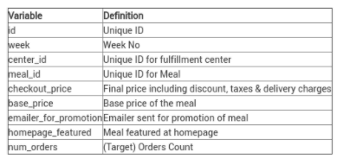

test.csv: Contains information like id, week, center id, meal id, checkout price, base price, emailer for promotion, homepage featured. This file is used for testing

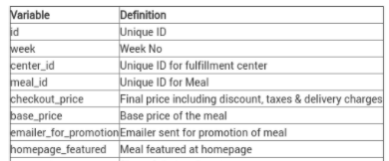

fulfilment_center_info.csv: Contains information of each fulfilment center

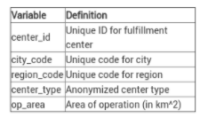

meal_info.csv: Contains information of each meal being served.

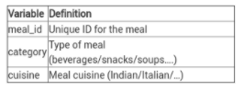

5.FLOW CHART

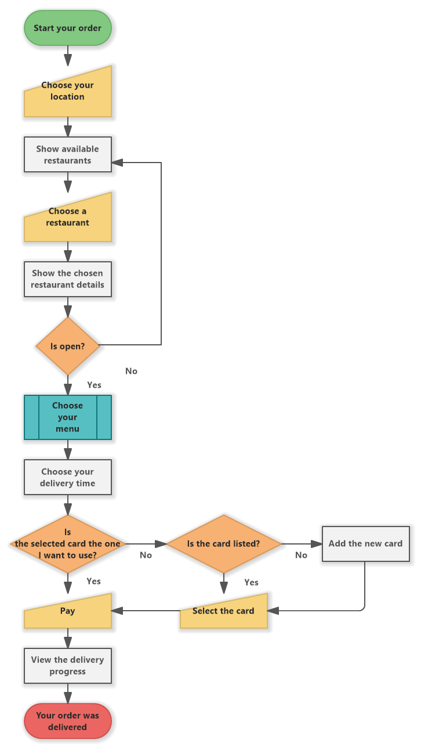

6.RESULTS

HOME PAGE:

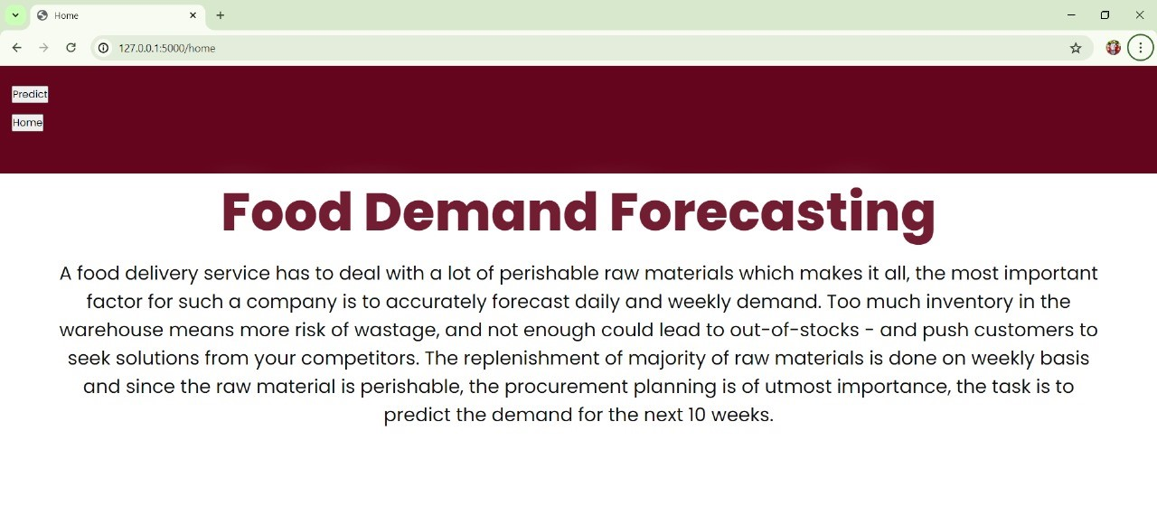  
 PREDICTIONS:

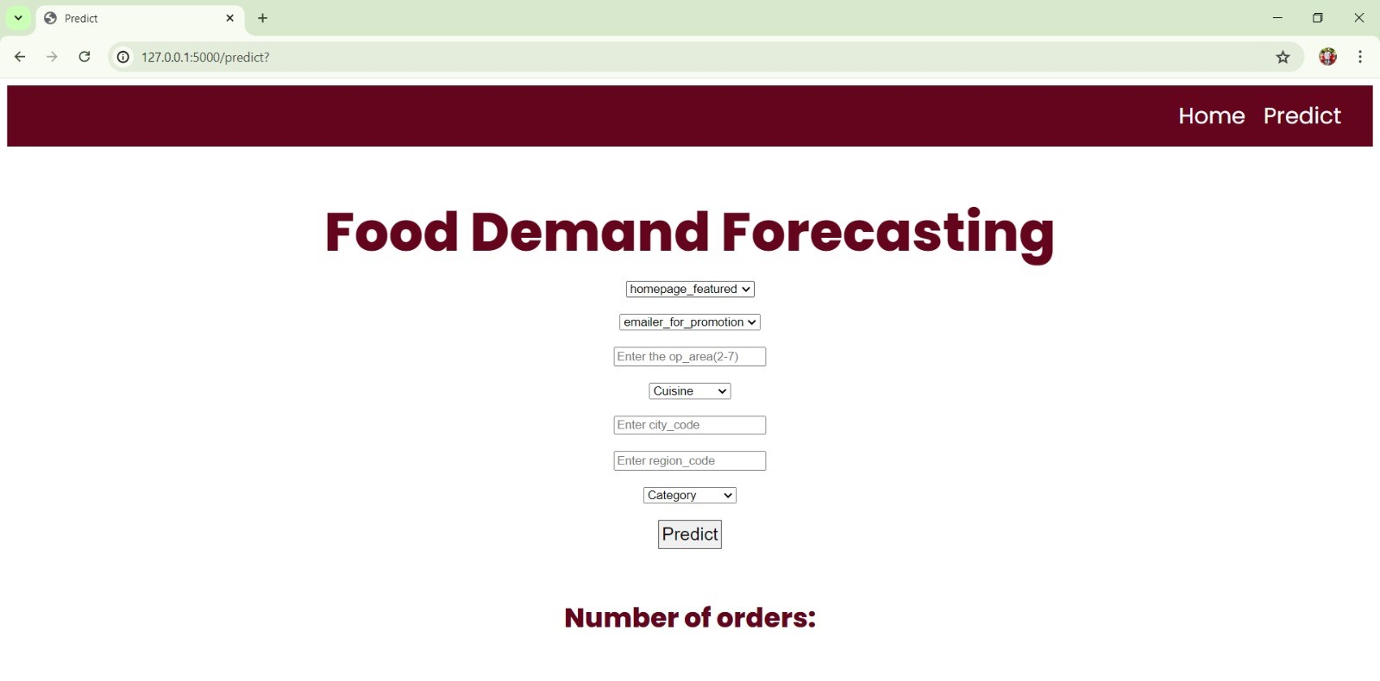

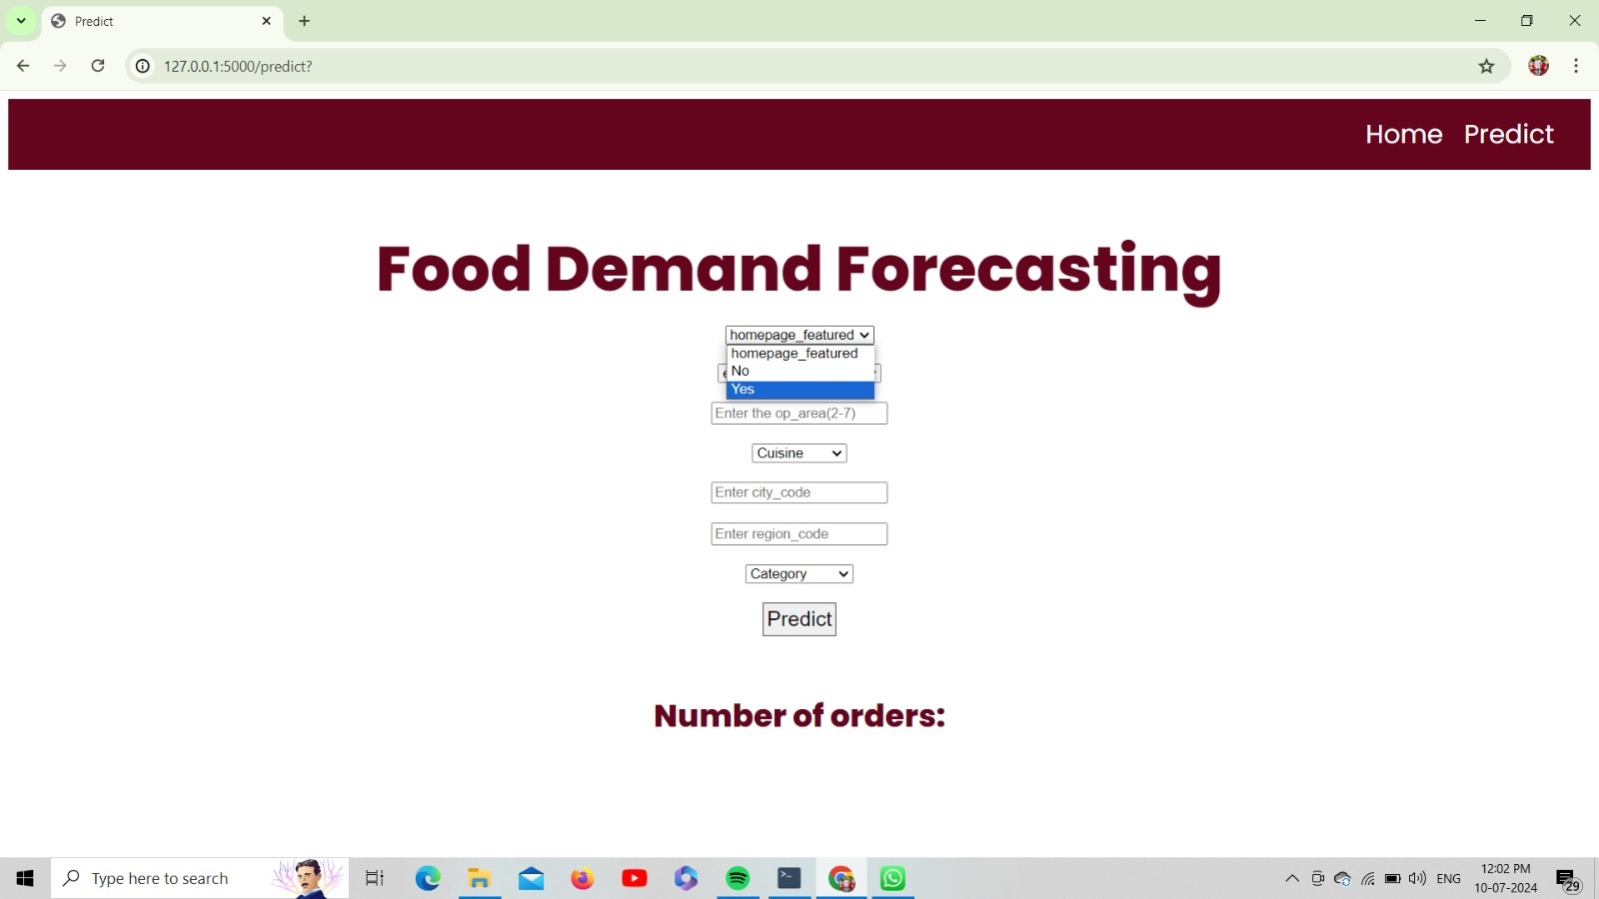

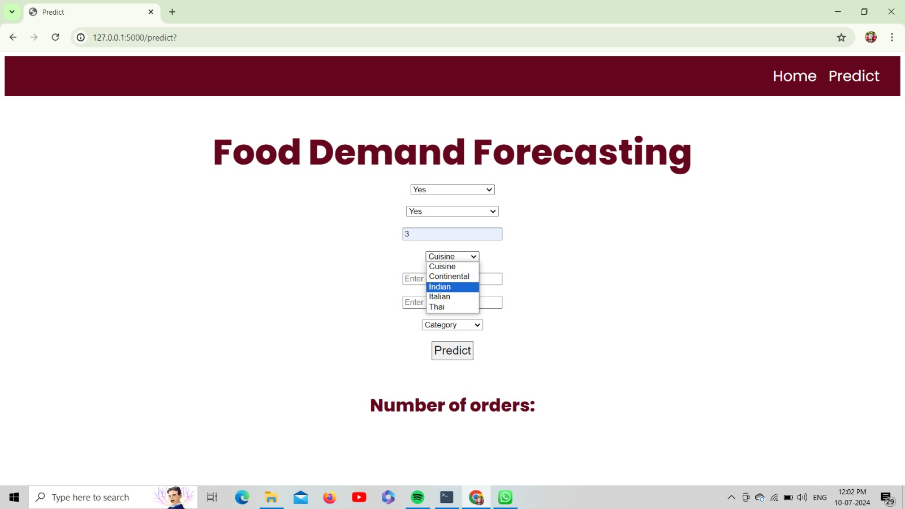

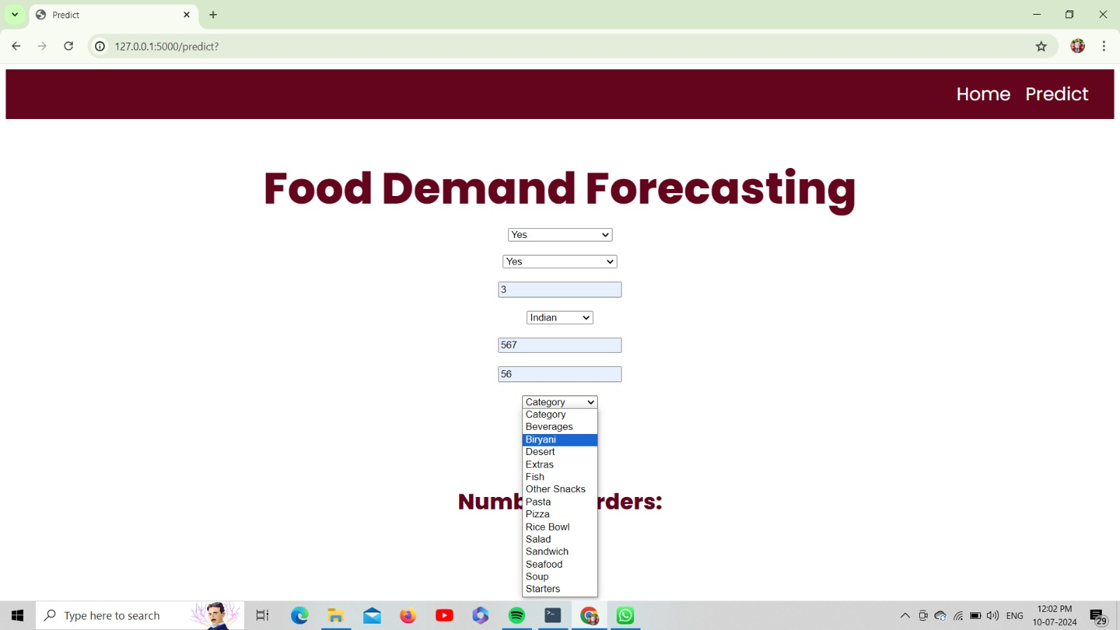

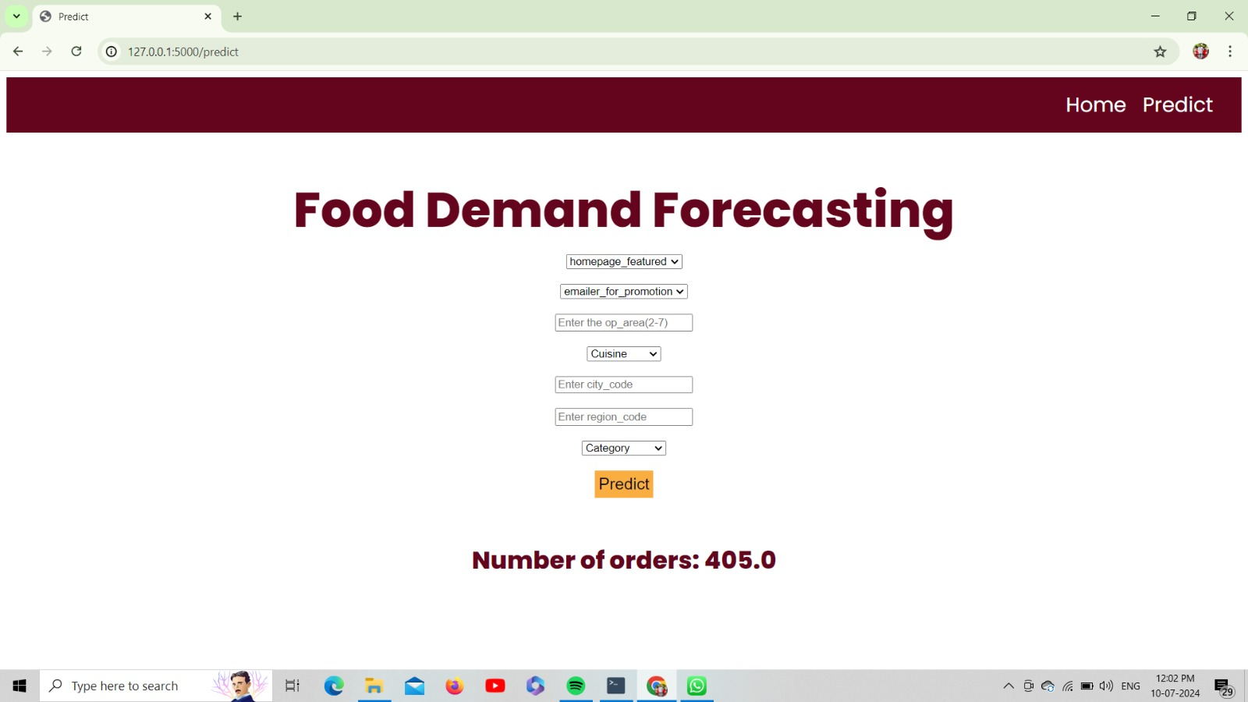

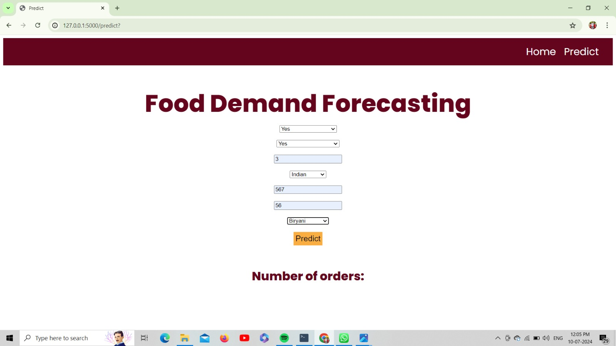

7.ADVANTAGES AND DISADVANTAGES

Advantages

1. *Inventory Management*: Accurate demand forecasting helps maintain optimal inventory levels, reducing waste and ensuring that fresh ingredients are always available.

2. *Cost Efficiency*: By predicting demand, companies can better manage their supply chain and reduce costs associated with over-ordering or under-ordering ingredients.

3. *Improved Customer Satisfaction*: Meeting customer demand consistently can lead to higher satisfaction and loyalty. Accurate forecasting ensures that popular items are always available and reduces delivery times.

4. *Resource Allocation*: It helps in efficient allocation of resources like staffing and delivery vehicles, ensuring that the company can handle peak times effectively without overstaffing during slower periods.

5. *Operational Efficiency*: Streamlined operations and better planning lead to improved overall efficiency, reducing delays and enhancing service quality.

6. *Strategic Planning*: Long-term demand trends can inform strategic decisions such as menu changes, marketing campaigns, and expansion plans.

Disadvantages

1. *Initial Costs and Complexity*: Setting up a sophisticated demand forecasting system can be costly and complex, requiring investment in technology and skilled personnel.

2. *Data Quality and Availability*: Accurate forecasting depends on high-quality data. Incomplete or inaccurate data can lead to incorrect forecasts and poor decision-making.

3. *Market Variability*: Unpredictable factors such as sudden changes in consumer preferences, market trends, or economic conditions can make forecasting challenging and sometimes inaccurate.

4. *Over-reliance on Technology*: Heavy reliance on forecasting models may lead to overlooking qualitative insights and intuition, which are also important in understanding market dynamics.

5. *Adaptability Issues*: Rapid changes in the market or unexpected events (e.g., pandemics, natural disasters) can render forecasts obsolete, requiring quick adaptation and flexibility.

6. *Customer Behavior Unpredictability*: Changes in customer behavior, driven by factors like new competitors,

promotional offers, or changing tastes, can be hard to predict accurately.

8.APPLICATIONS:

### 1. *Inventory Management*

- *Stock Optimization*: Ensure that the right amount of ingredients and food items are available, minimizing waste and avoiding stockouts.

- *Supplier Coordination*: Better forecasting allows for more accurate and timely orders from suppliers, maintaining a steady supply chain.

### 2. *Menu Planning*

- *Popular Dishes*: Identify which dishes are in high demand to prioritize their availability.

- *Seasonal Adjustments*: Adjust the menu based on seasonal trends and expected demand for certain items.

### 3. *Staffing and Labor Management*

- *Shift Scheduling*: Align staff schedules with predicted busy times to ensure adequate staffing levels.

- *Labor Cost Control*: Avoid overstaffing during slow periods and understaffing during peak times, optimizing labor costs.

### 4. *Delivery Logistics*

- *Route Optimization*: Plan delivery routes based on expected order volumes and locations to improve efficiency and reduce delivery times.

- *Capacity Planning*: Ensure the right number of delivery vehicles are available to handle peak demand periods.

### 5. *Marketing and Promotions*

- *Targeted Campaigns*: Use demand forecasts to launch promotions during expected low-demand periods to boost sales.

- *Customer Segmentation*: Tailor marketing efforts based on forecasted preferences of different customer segments.

### 6. *Pricing Strategy*

- *Dynamic Pricing*: Adjust prices based on predicted demand to maximize revenue during peak times and attract customers during slower periods.

- *Promotional Discounts*: Offer discounts on items that are forecasted to have lower demand to stimulate sales.

### 7. *Financial Planning*

- *Revenue Projections*: Accurate forecasting helps in predicting future revenue, aiding in financial planning and budgeting.

- *Cost Management*: Better predict operational costs related to food procurement, staffing, and logistics.

### 8. *Customer Experience Enhancement*

- *Personalized Offers*: Use forecasts to send personalized recommendations and offers to customers based on their predicted preferences.

- *Consistent Availability*: Ensure that high-demand items are consistently available, improving customer satisfaction and loyalty.

### 9. *Strategic Decision-Making*

- *Expansion Plans*: Identify trends and patterns to inform decisions about opening new delivery zones or locations.

- *Product Development*: Develop new menu items based on anticipated customer preferences and demand trends.

9.CONCLUSION

In conclusion, food demand forecasting is an essential tool for food delivery companies, offering significant benefits that enhance various aspects of their operations. Accurate forecasting enables optimal inventory management, cost efficiency, and improved customer satisfaction. It allows for better resource allocation, operational efficiency, and strategic planning. While there are challenges such as initial costs, data quality issues, and market variability, the advantages far outweigh the disadvantages when effectively implemented.

By leveraging demand forecasting, food delivery companies can streamline their supply chains, reduce waste, and ensure timely delivery of popular menu items. This leads to higher customer loyalty and a competitive edge in the market. Moreover, it supports informed decision-making for menu planning, marketing strategies, pricing, and expansion plans. Overall, food demand forecasting is a vital component in driving the success and sustainability of food delivery businesses in a dynamic market environment.

10.FUTURE SCOPE

The future scope of food demand forecasting for food delivery companies is promising and expansive, driven by advancements in technology, data analytics, and changing consumer behaviors. Here are some key areas for future development:

### 1. *Enhanced Predictive Models*

- *Artificial Intelligence and Machine Learning*: Continued advancements in AI and machine learning will lead to more sophisticated and accurate predictive models, capable of analyzing vast amounts of data and identifying complex patterns.

- *Real-time Data Integration*: Incorporating real-time data from various sources such as social media, weather forecasts, and current events to improve the accuracy of demand predictions.

### 2. *Personalization*

- *Customer Behavior Analysis*: Deeper insights into individual customer preferences and behaviors will enable highly personalized recommendations and offers, enhancing customer satisfaction and loyalty.

- *Dynamic Menu Adjustments*: Real-time adjustments to the menu based on current demand forecasts and customer preferences.

### 3. *Sustainability and Waste Reduction*

- *Zero-Waste Initiatives*: More precise demand forecasting can contribute to zero-waste initiatives by minimizing food waste and optimizing resource use.

- *Sustainable Sourcing*: Forecasting can help in planning and sourcing ingredients sustainably, reducing the environmental impact of food delivery operations.

### 4. *Integration with IoT and Smart Technologies*

- *Smart Kitchens*: Integration with Internet of Things (IoT) devices in smart kitchens to monitor inventory levels, predict equipment maintenance needs, and streamline food preparation processes.

- *Automated Inventory Management*: Automated systems that adjust orders and stock levels in real-time based on forecasted demand.

### 5. *Advanced Analytics and Insights*

- *Big Data Analytics*: Utilizing big data analytics to gain deeper insights into market trends, customer preferences, and operational efficiencies.

- *Predictive Analytics for New Markets*: Expanding forecasting capabilities to explore and predict demand in new markets and regions.

### 6. *Improved Logistics and Delivery Systems*

- *Autonomous Delivery Vehicles*: Forecasting integrated with autonomous delivery vehicles and drones for efficient and timely delivery.

- *Smart Routing*: Advanced algorithms for optimizing delivery routes based on real-time traffic data and demand forecasts.

### 7. *Enhanced Customer Experience*

- *Virtual Assistants*: Use of AI-driven virtual assistants to interact with customers, taking orders, and making recommendations based on demand forecasts.

- *Augmented Reality (AR) Menus*: Interactive AR menus that can change dynamically based on predicted demand and customer preferences.

### 8. *Collaboration and Data Sharing*

- *Shared Data Platforms*: Collaboration with suppliers and partners through shared data platforms to improve the accuracy of demand forecasts and streamline the supply chain.

- *Industry-wide Initiatives*: Participation in industry-wide initiatives to develop standardized forecasting methods and share best practices.

### 9. *Regulatory Compliance and Safety*

- *Predictive Compliance*: Using forecasting models to predict and ensure compliance with health, safety, and regulatory standards.

- *Food Safety Tracking*: Enhanced tracking of food safety throughout the supply chain, predicting and preventing potential issues before they arise.

### 10. *Global Expansion and Market Adaptation*

- *Cross-Cultural Insights*: Adapting forecasting models to different cultural and regional preferences as companies expand globally.

- *Localized Forecasting*: Developing localized forecasting techniques to cater to the unique demands of different markets.

Embracing these future trends and innovations will enable food delivery companies to stay competitive, enhance customer satisfaction, and operate more sustainably and efficiently in an ever-evolving market landscape.

11.BIBILOGRAPHY

1. *Agrawal, A., Gans, J., & Goldfarb, A. (2018).* Prediction Machines: The Simple Economics of Artificial Intelligence. Harvard Business Review Press.

- Discusses the role of AI in predictive analytics and its economic implications, relevant to demand forecasting.

2. *Chopra, S., & Meindl, P. (2016).* Supply Chain Management: Strategy, Planning, and Operation. Pearson.

- Covers supply chain strategies and operations, including demand forecasting techniques.

3. *Davenport, T. H., & Harris, J. G. (2017).* Competing on Analytics: Updated, with a New Introduction: The New Science of Winning. Harvard Business Review Press.

- Explores how companies can leverage analytics for competitive advantage, including forecasting.

4. *Fildes, R., & Goodwin, P. (2021).* "The Impact of Forecasting on Operational Performance." International Journal of Forecasting, 37(2), 715-729.

- Examines the impact of forecasting accuracy on operational performance in businesses.

5. *Fisher, M. L., & Raman, A. (2010).* "The New Science of Retailing: How Analytics are Transforming the Supply Chain and Improving Performance." Harvard Business Review Press.

- Focuses on the role of analytics in retail and supply chain management, relevant to food delivery services.

6. *Gartner. (2022).* "Market Guide for Supply Chain Planning Solutions." Gartner Research.

- Provides insights into current technologies and solutions for supply chain planning and forecasting.

7. *Kumar, S., & Sharman, G. (2019).* Essentials of Supply Chain Management. Wiley.

- A comprehensive guide to supply chain management, including demand forecasting methodologies.

8. *Lapide, L. (2020).* "Demand Management: A Critical Factor for Supply Chain Performance." Journal of Business Logistics, 41(2), 119-133.

- Discusses demand management and its importance for supply chain performance.

9. *Makridakis, S., Wheelwright, S. C., & Hyndman, R. J. (2018).* Forecasting: Methods and Applications. Wiley.

- Detailed coverage of various forecasting methods and their applications in business.

10. *Sodhi, M. S., & Tang, C. S. (2021).* Managing Supply Chain Risk and Disruptions: Lessons Learned from the COVID-19 Pandemic. Springer.

- Explores risk management and supply chain disruptions, with a focus on forecasting during uncertain times.

11. *Taylor, J. W. (2017).* "Forecasting Energy Demand: A Review of Approaches." International Journal of Forecasting, 33(2), 570-587.

- Reviews various approaches to forecasting demand, applicable to food delivery companies for energy and resource management.

12. *Waller, M. A., & Fawcett, S. E. (2013).* "Data Science, Predictive Analytics, and Big Data: A Revolution That Will Transform Supply Chain Design and Management." Journal of Business Logistics, 34(2), 77-84.

- Discusses the role of big data and predictive analytics in transforming supply chain management.

These references provide a comprehensive understanding of demand forecasting, its methodologies, and applications in the context of food delivery and broader supply chain management.

12.APPENDIX

Model building :

1.Dataset

2.Google colab and VS code Application Building

1.HTML file(home file,update file)

2.CSS file

3.Models in pickle file

SOURCE CODE:

HOME.HTML

<!DOCTYPE html>

<html lang="en">

<head>

    <meta charset="UTF-8">

    <meta http-equiv="X-UA-Compatible" content="IE=edge">

    <meta name="viewport" content="width=device-width, initial-scale=1.0">

    <title>Home</title>

    <link type="text/css" rel="stylesheet" href="/Flask/static/style.css">

    <link rel="preconnect" href="https://fonts.googleapis.com">

<link rel="preconnect" href="https://fonts.gstatic.com" crossorigin>

<link href="https://fonts.googleapis.com/css2?family=Poppins:wght@200;300;400;600;800&display=swap" rel="stylesheet">

<link rel="stylesheet" href="https://cdnjs.cloudflare.com/ajax/libs/font-awesome/6.0.0-beta2/css/all.min.css">

<link rel="stylesheet" href="https://cdnjs.cloudflare.com/ajax/libs/font-awesome/6.0.0-beta2/css/v4-shims.min.css">

<style>

*{

    margin: 0;

    padding: 0;

    font-family: 'Poppins', sans-serif;

}

.bar

{

margin: 0px;

padding: 15px;

background-color:rgb(100, 5, 29);

font-family:'Poppins',sans-serif;

font-size:25px;

}

a{

color:#fff;

float:right;

text-decoration:none;

padding-right:20px;

}

a:hover{

    padding: 3.5px;

    background: #FAAE42;

}

.text-box{

    width: 90%;

    color:rgba(100, 5, 29, 0.905);

    text-shadow: #0c0d0e;

    position:absolute;

    top: 45%;

    left: 50%;

    transform: translate(-50%,-50%);

    text-align: center;

}

.text-box h1{

    font-size: 70px;

    text-shadow: 2px 2px 40px #ffffff;

}

.text-box p{

    margin: 10px 0 40px;

    font-size: 25px;

    color: rgba(0, 0, 0, 0.946);

}

</style>

</head>

<body>

   <section class="header">

    <div class="bar">

        <a href="upload.html">Predict</a>

        <a href="/home">Home</a>

    <br>

         </div>

       <div class="text-box">

        <h1>Food Demand Forecasting</h1>

        <p>A food delivery service has to deal with a lot of perishable raw materials which makes it all,

            the most important factor for such a company is to accurately forecast daily and weekly demand.

            Too much inventory in the warehouse means more risk of wastage, and not enough could lead to out-of-stocks -

            and push customers to seek solutions from your competitors.

            The replenishment of majority of raw materials is done on weekly basis and since the raw material is perishable,

            the procurement planning is of utmost importance, the task is to predict the demand for the next 10 weeks.</p>

    </div>

   </section>

</body>

</html>

UPDATE.HTML

<html lang="en">

<head>

    <meta charset="UTF-8">

    <meta http-equiv="X-UA-Compatible" content="IE=edge">

    <meta name="viewport" content="width=device-width, initial-scale=1.0">

    <title>Predict</title>

    <link rel="preconnect" href="https://fonts.googleapis.com">

<link rel="preconnect" href="https://fonts.gstatic.com" crossorigin>

<link href="https://fonts.googleapis.com/css2?family=Poppins:wght@200;300;400;600;800&display=swap" rel="stylesheet">

<link rel="stylesheet" href="https://cdnjs.cloudflare.com/ajax/libs/font-awesome/6.0.0-beta2/css/all.min.css">

<style>

.bar

{

margin: 0px;

padding: 15px;

background-color:rgb(100, 5, 29);

/* opacity:0.6; */

font-family:'Poppins',sans-serif;

font-size:25px;

}

a

{

color:#fff;

float:right;

text-decoration:none;

padding-right:20px;

}

a:hover{

    padding: 3.5px;

    background: #FAAE42;

}

h1{

    color:rgb(100, 5, 29);

    font-family:Poppins;

    font-size:30

}

h2{

    color:rgb(100, 5, 29);

    font-family: Poppins;

    font-size:60;

    margin-bottom: 10px;

}

.my-cta-button{

    font-size: 20px;

    color: rgb(15, 15, 15);

    border: 1px solid #0e0e0ccf;

    padding: 3.5px;

    cursor: pointer;

}

.my-cta-button:hover{

    border: 2px solid #faae42;

    padding: 3.5px;

    background: #FAAE42;

}

p

{

color:white;

font-family: Poppins;

font-size:30px;

}

</style>

</head>

<body>

    <div class="bar">

      <a href="/pred">Predict</a>

      <a href="/home">Home</a>

     <br>

        </div>

    <div class="container">

            <center> <div id="content" style="margin-top:2em">

            <h2><center>Food Demand Forecasting</center></h2>

                 <form action="{{ url_for('predict') }}" method="POST">

     <select id="homepage_featured" name="homepage_featured">

      <option value="">homepage_featured</option>

         <option value="0">No</option>

         <option value="1">Yes</option>

       </select><br><br>

     <select id="emailer_for_promotion" name="emailer_for_promotion">

      <option value="">emailer_for_promotion</option>

         <option value="0">No</option>

         <option value="1">Yes</option>

       </select><br><br>

     <input class="form-input" type="text" name="op_area" placeholder="Enter the op_area(2-7)"><br><br>

     <select id="cuisine" name="cuisine">

     <option value="">Cuisine</option>

         <option value="0">Continental</option>

         <option value="1">Indian</option>

         <option value="2">Italian</option>

         <option value="3">Thai</option>

       </select><br><br>

       <input class="form-input" type="text" name="city_code" placeholder="Enter city_code"><br><br>

     <input class="form-input" type="text" name="region_code" placeholder="Enter region_code"><br><br>

     <select id="category" name="category">

     <option value="">Category</option>

         <option value="0">Beverages</option>

         <option value="1">Biryani</option>

         <option value="2">Desert</option>

         <option value="3">Extras</option>

         <option value="4">Fish</option>

         <option value="5">Other Snacks</option>

         <option value="6">Pasta</option>

         <option value="7">Pizza</option>

         <option value="8">Rice Bowl</option>

         <option value="9">Salad</option>

         <option value="10">Sandwich</option>

         <option value="11">Seafood</option>

         <option value="12">Soup</option>

         <option value="13">Starters</option>

       </select><br><br>

                     <input type="submit" class="my-cta-button" value="Predict">

                 </form>

         <br>

          <h1 class="predict">Number of orders: {{ prediction_text }}</h1>

            </div></center>

         </div>

     </body>

</body>

APP.PY

# import the necessary packages

import pandas as pd

import numpy as np

import pickle

import os

from flask import Flask,request, render_template

app=Flask(__name__,template_folder="templates")

@app.route('/',methods=['GET'])

def index():

    return render_template('home.html')

@app.route('/home',methods=['GET'])

def about():

    return render_template('home.html')

@app.route('/pred',methods=['GET'])

def page():

    return render_template('upolad.html')

@app.route('/predict', methods=['GET','POST'])

def predict():

    # print("[INFO] loading model...")

    model = pickle.load(open('demand.pkl','rb'))

    input_features = [float(x) for x in request.form.values()]

    features_value = [np.array(input_features)]

    print(features_value)

    features_name = ['homepage_features','emailer_for_promotion','op_area','cuisine','city_code','region_code','category']

    prediction = model.predict(features_value)

    output=prediction[0]

    # print(output)

    return render_template('upload.html',prediction_text=output)

if __name__ == '__main__':

  app.run(debug=True)

CODE SNIPPETS

MODEL BUILDING

